**Modelling the EnduroSat UHF Antenna Type III with Ansys HFSS**

June 28th 2024

Kira Allen

k[alle5@uwo.ca](mailto:Kalle5@uwo.ca)

**Purpose**

* Predict influence of 3U structure
* Gauge impact of deployment fail cases
* Create gain plots for IARU licensing

**Assumptions**

|  |  |
| --- | --- |
| Assumption | Justification |
| Antenna radius 1 mm | Somewhat arbitrary, to fit in CAD model |
| Material for antenna: copper | SMA with low Af temperature to align with operating temperature are commonly made of copper |
| Antenna length: 0.330275229 m | Half wavelength at 436 MHz, reduced by 4% |
| Lumped port excitation | The tutorial used it |
| PML for boundaries | Again, following tutorial |
| Frequency sweep 406-466 MHz | This should cover 436 and is short enough that the simulations aren’t excessively long |
| Frequency of analysis 436 MHz | Within the 435.000 – 438.000 MHz amateur band for satellites |
| 0.5 W for each port | Total is 1 W |
| One cylinder phase shifted by 90 degrees | Circular polarization |
| CubeSat structure and antenna case simplified significantly, with the largest components retained | Screws and other pieces complicated simulations |

**Refinements needed**

* Internal geometry of the antennas
* The material the antenna is made from
* Antenna length
* Check polarization is the correct handedness

**Guide to Versions**

|  |  |
| --- | --- |
| **V2\*** | **Basic model. Two crossed copper dipoles, vacuum in the middle with a lumped port, 90 degree phase shift. One antenna is 2mm above the other in this model, since intersecting parts are not permitted, but the actual antennas are on the same plane.** |
| V3 | Geometry of the Endurosat antenna case with the doors open, simplified by deleting components that intersected on the original model. |
| V4 | Simpler version of V3 with only the plates of the antenna case, in aluminum. |
| V5 | The antenna case in V3 was replaced with a block of solid aluminum. |
| V6 | The crossed dipoles were mounted on top of a simplified aluminum 3U structure. It is typical in literature for just the structure to be used for simulations. Many components such as screws were deleted to avoid intersecting parts. |
| **V7\*** | **V2 model with 3U structure and plate. A combination of V6 and V3, two crossed dipoles between the antenna case plates on top of a simplified 3U structure.** |
| V8 | The first antenna deployment failure, where one antenna does not deploy. This half of the dipole was deleted. Aluminum antenna case plates. |
| V9 | For efficiency, the plates were removed for this one antenna not deployed case. |
| V10 | As the non-deployed antenna is technically still able to radiate, it was modeled as a small torus. |
| **V11\*** | **Single antenna deployment failure. An improvement on V10, the torus was enlarged to improve accuracy and contact with lumped port was improved.** |
| **V12\*** | **Double antenna deployment failure, symmetrical case, with failing antennas across from each other and modeled with toruses.** |
| **V13\*** | **Double antenna deployment failure, asymmetrical case.** |
| **V14\*** | **Triple antenna deployment failure, asymmetrical case.** |
| V15 | Total antenna deployment failure. |
| **V16\*** | **Total antenna deployment failure with plates.** |

**\***Indicates the most relevant simulations.

**Basic Model (V2)**

Crossed dipoles
Crossed dipoles geometry

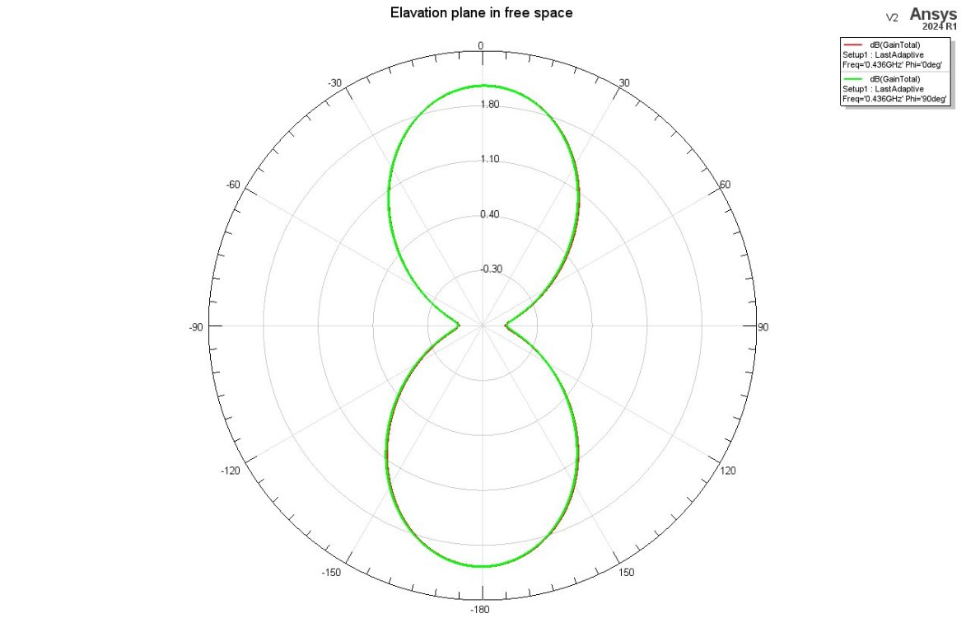Elevation plane gain

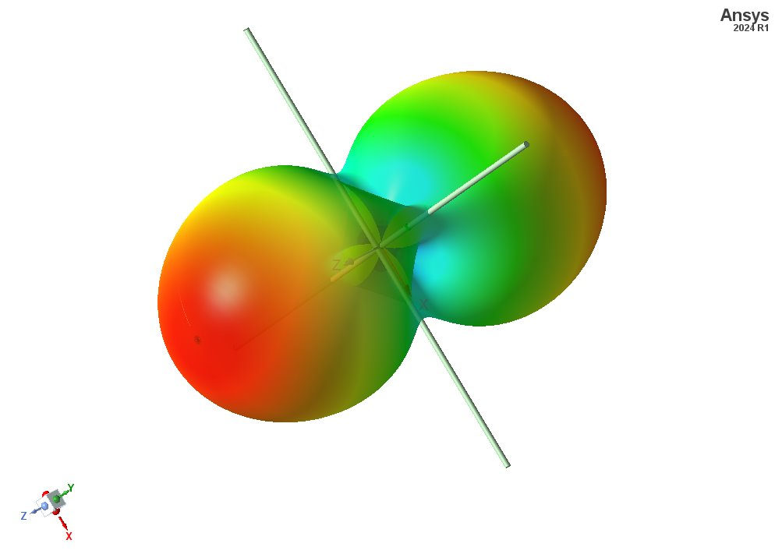3D radiation pattern

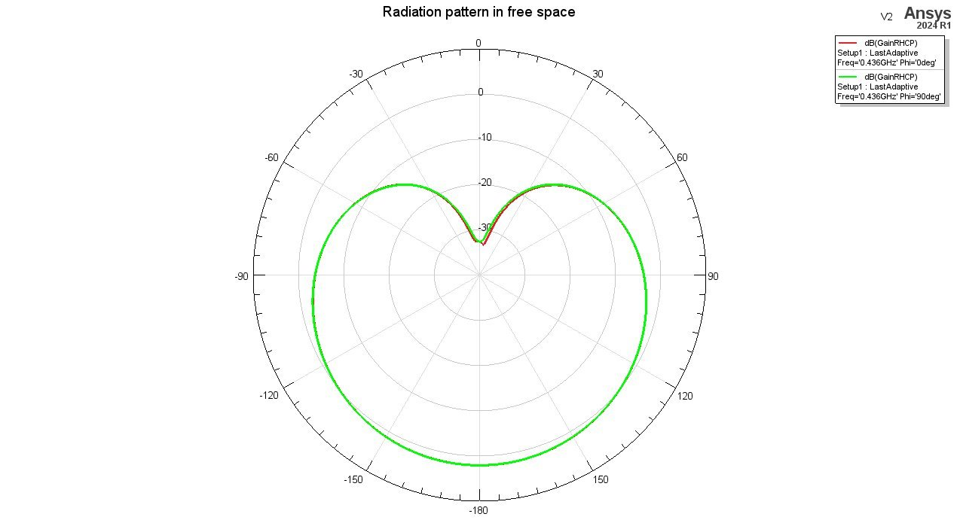

Circularly polarized elevation plane gain

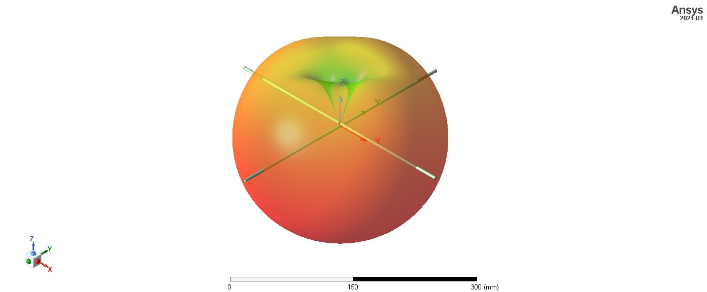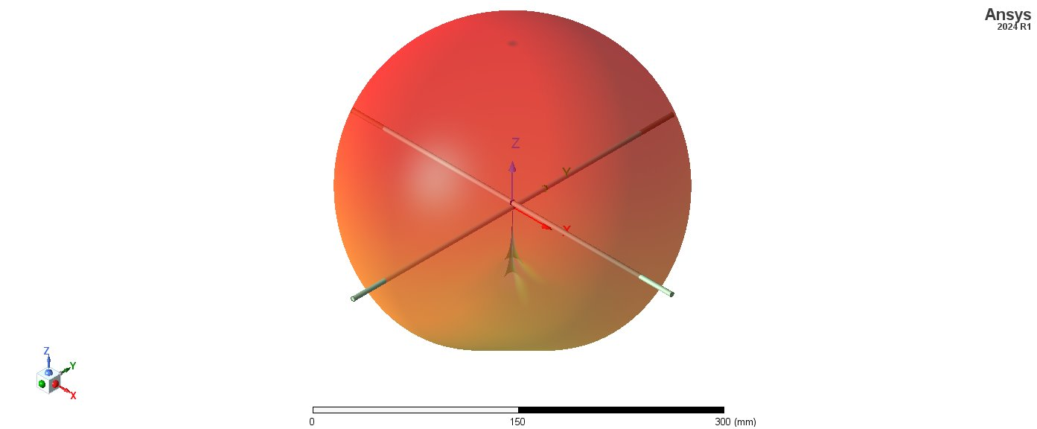3D circularly polarized radiation pattern (LHCP above, RHCP below)

**Crossed dipoles with 3U structure and antenna plates (V7)**

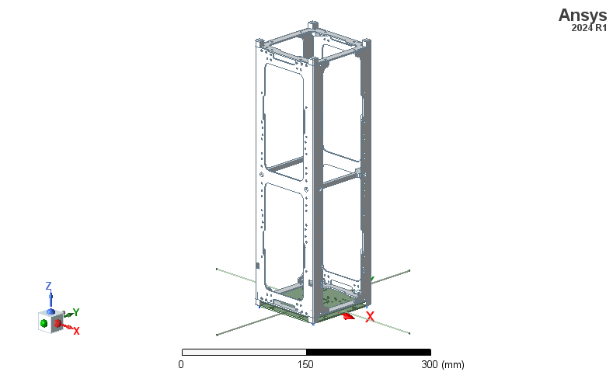Geometry of antenna case plates and 3U structure

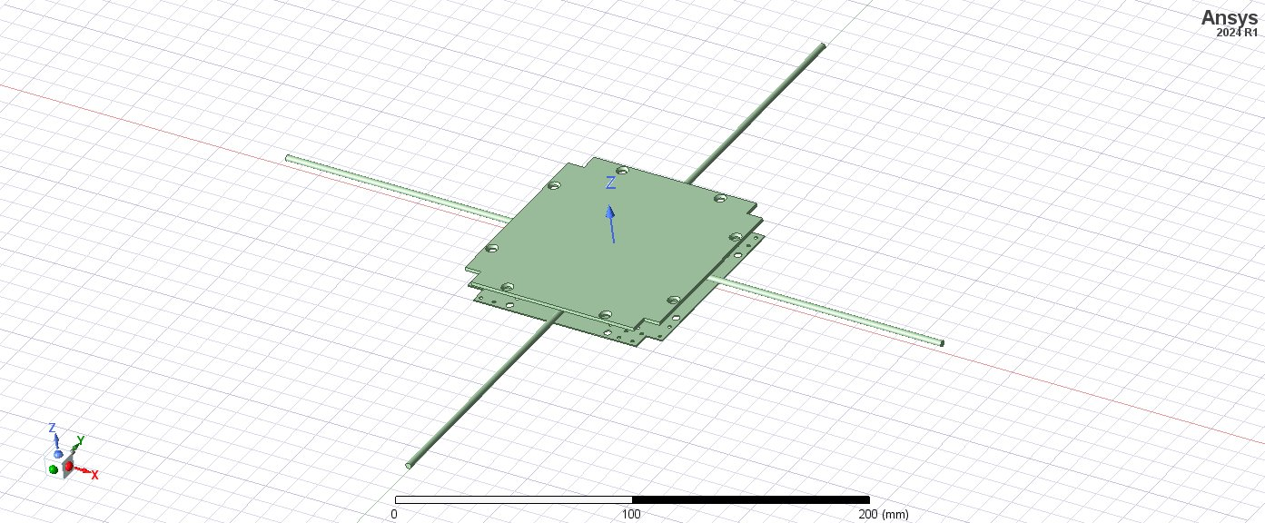Geometry of antenna case plates

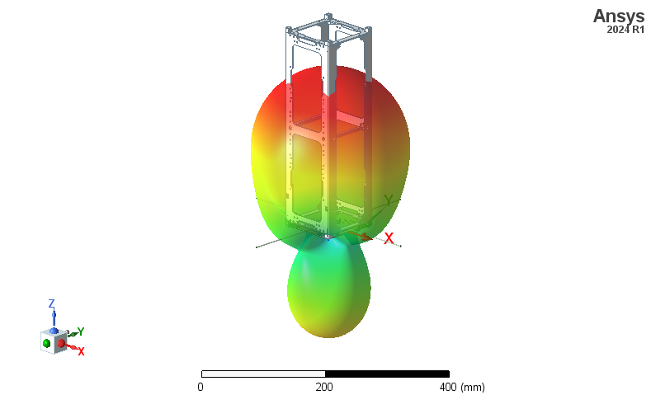3D radiation pattern

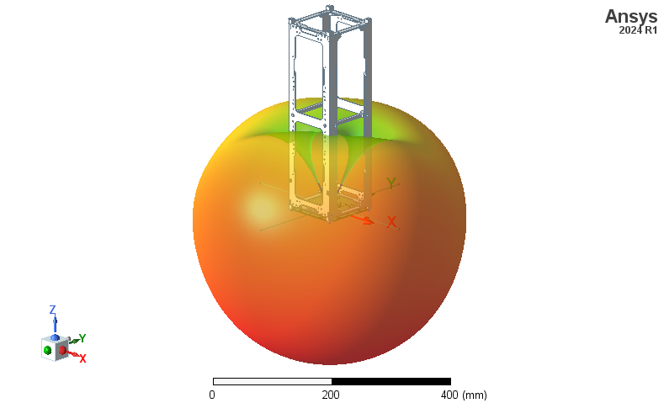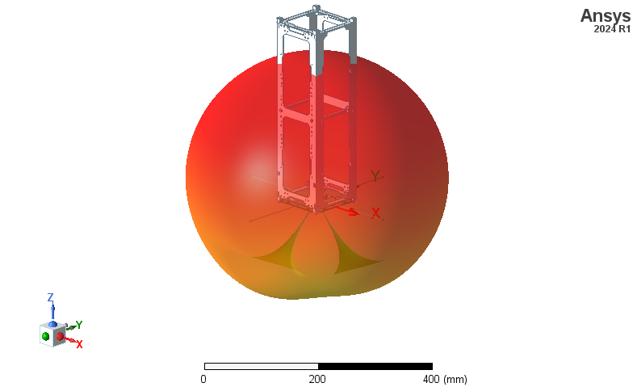3D Circularly polarized radiation pattern (LHCP above, RHCP below)

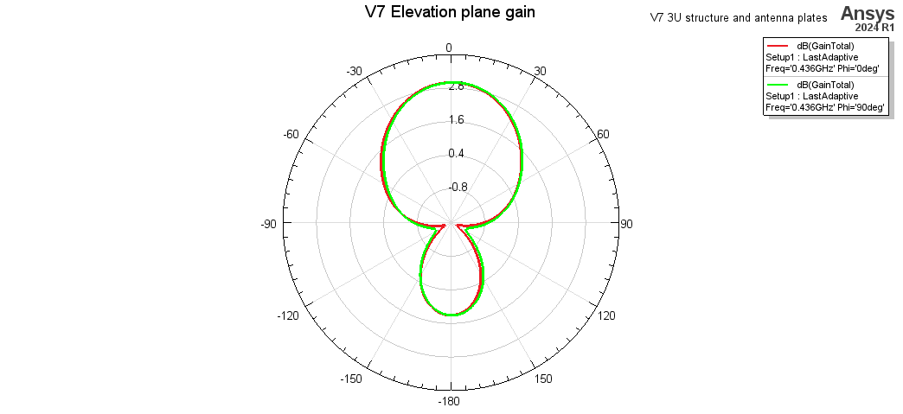Total Elevation plane gain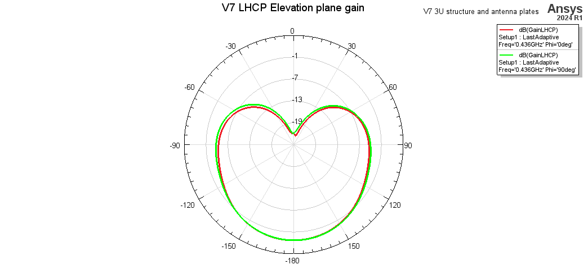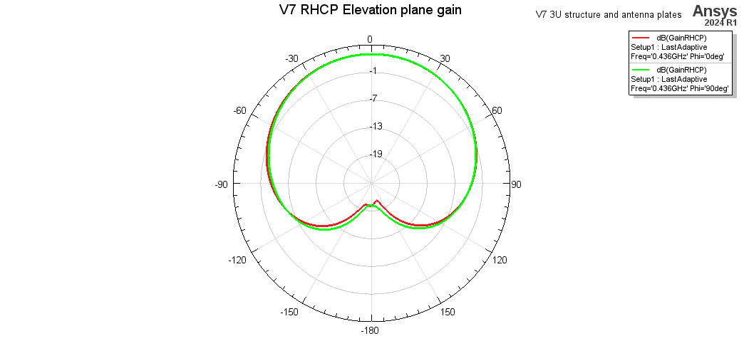Circularly polarized elevation plane gain (LHCP above, RHCP below)

**Single antenna deployment failure (V9, V10, V11)**

Comparing methods of modeling the stored antenna in the structure. The antenna is coiled inside the plates, so it was simplified as a loop directly touching the lumped port. V9 has no loop, V10 has a small loop, and V11 has an approximately to-scale loop.

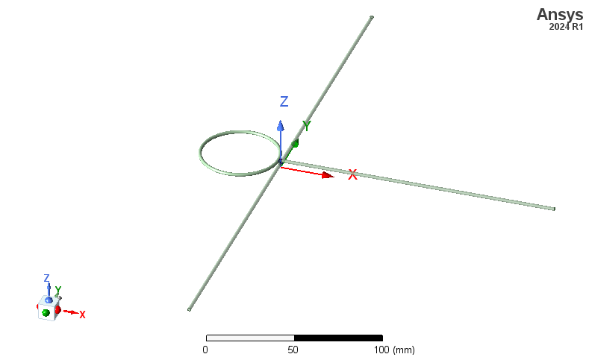

Geometry of V11

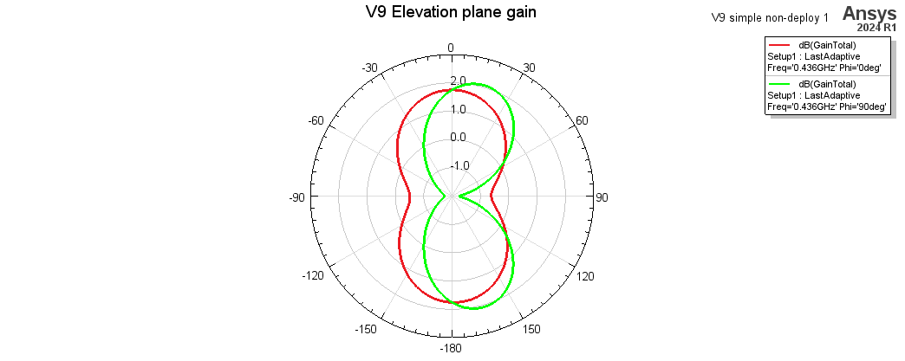

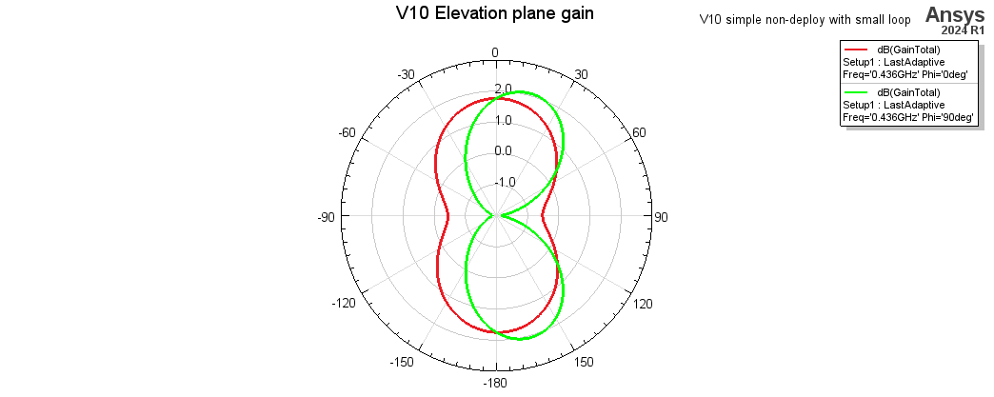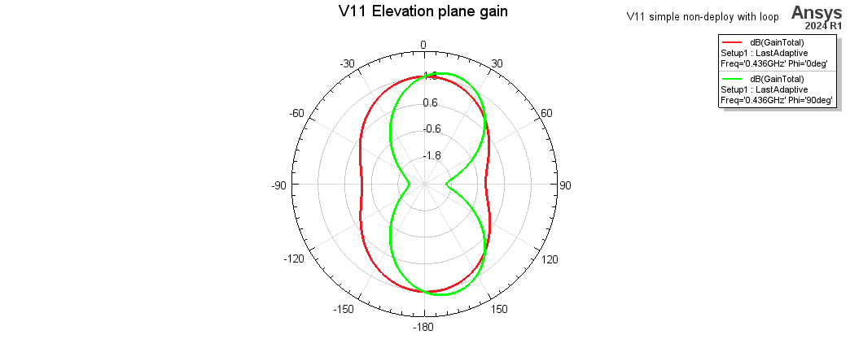Comparison of total elevation plane gain for various single deployment failure geometries.

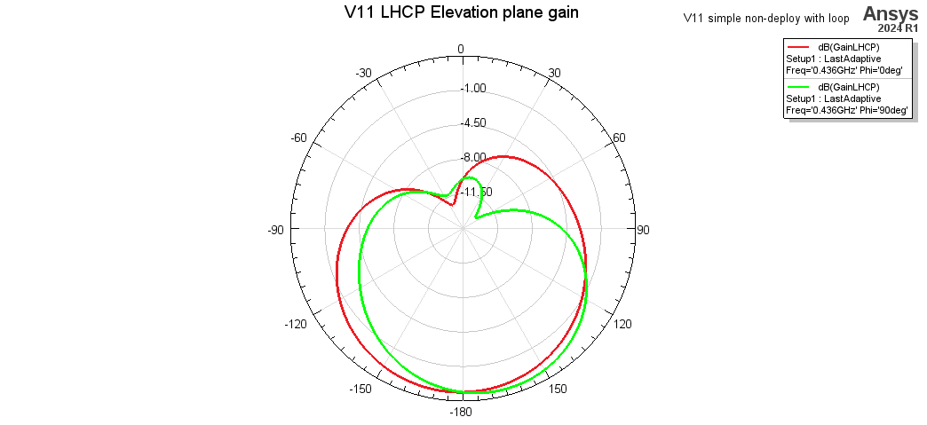

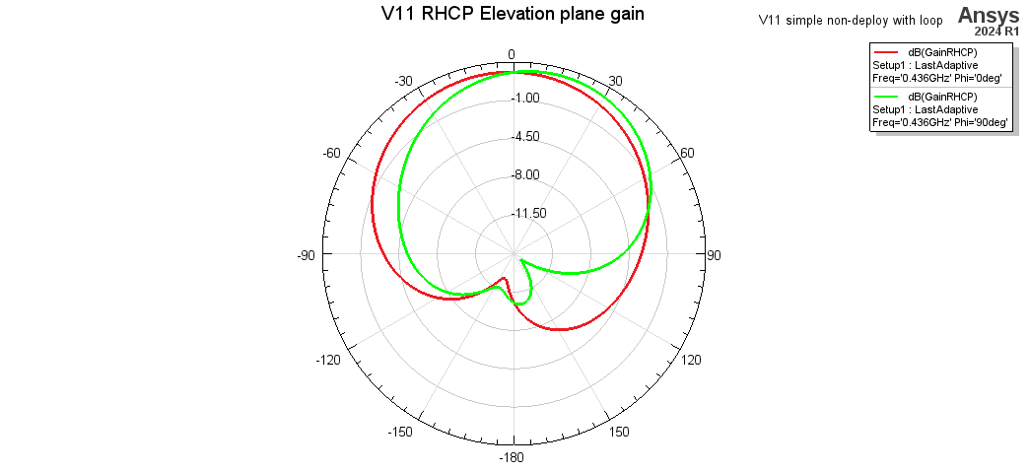

Circularly polarized elevation plane gain, (LHCP above, RHCP below)

**Double antenna deployment failure (V12, V13)**

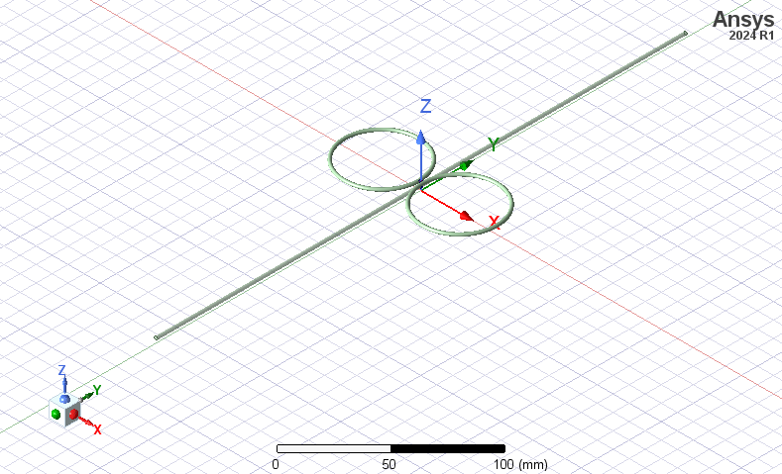Geometry of V12, symmetrical case

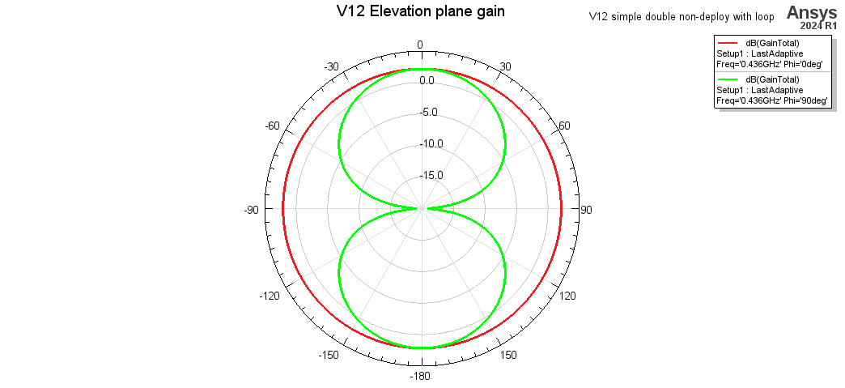

Elevation plane gain for double antenna deployment failure, symmetrical case

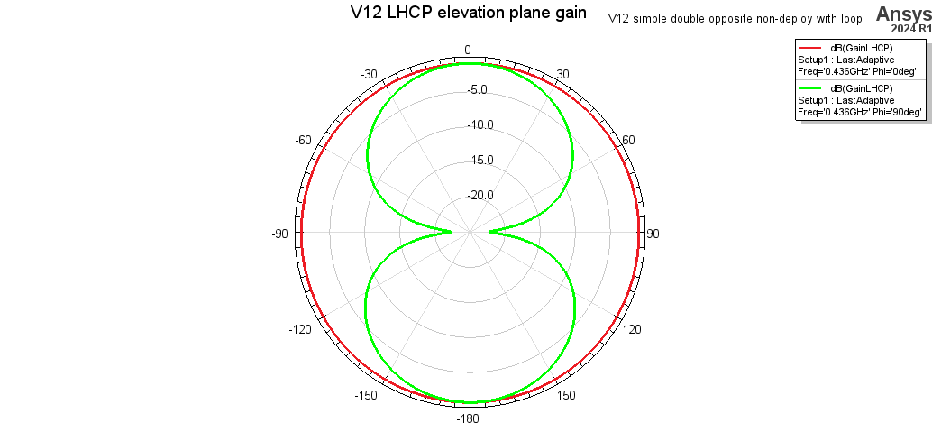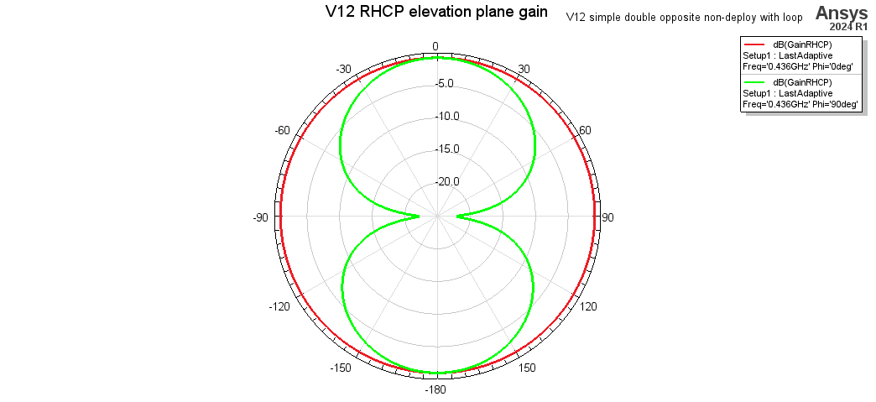

Circularly polarized elevation plane gain, (LHCP above, RHCP below)

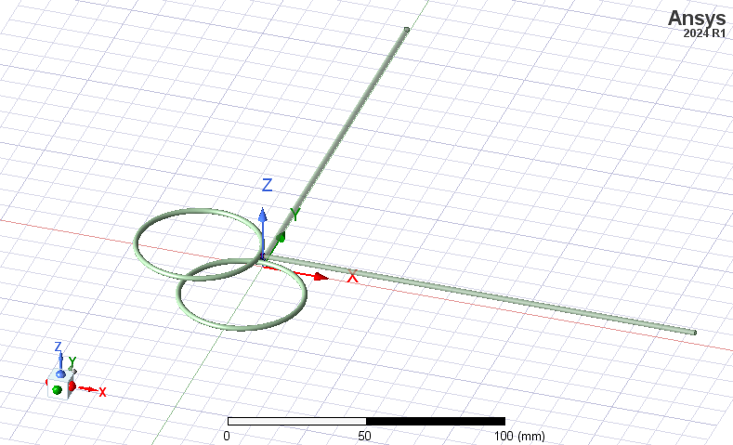Geometry of V13, asymmetrical case

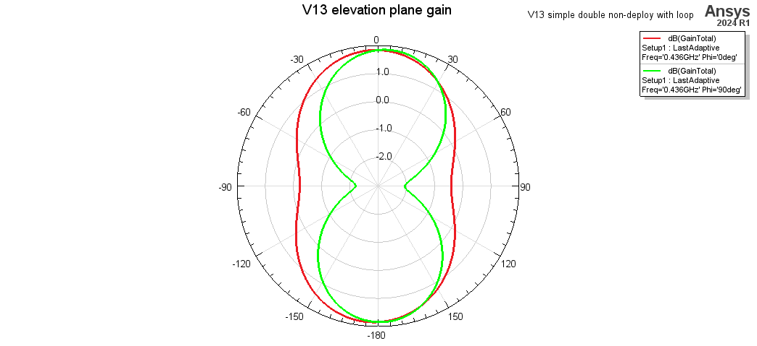Elevation plane gain for double antenna deployment failure, asymmetrical case

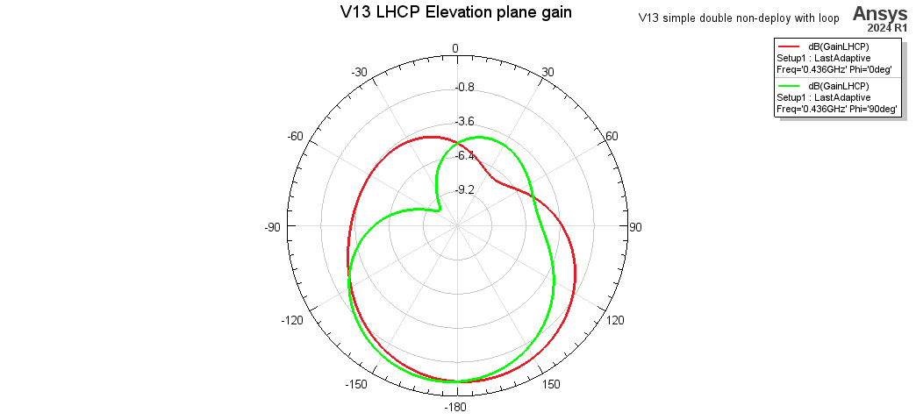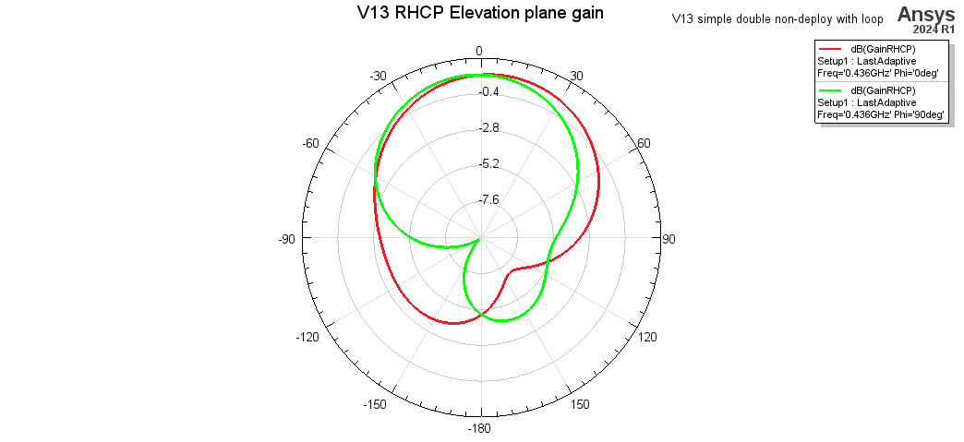Circularly polarized elevation plane gain, (LHCP above, RHCP below)

**Triple antenna deployment failure (V14)**

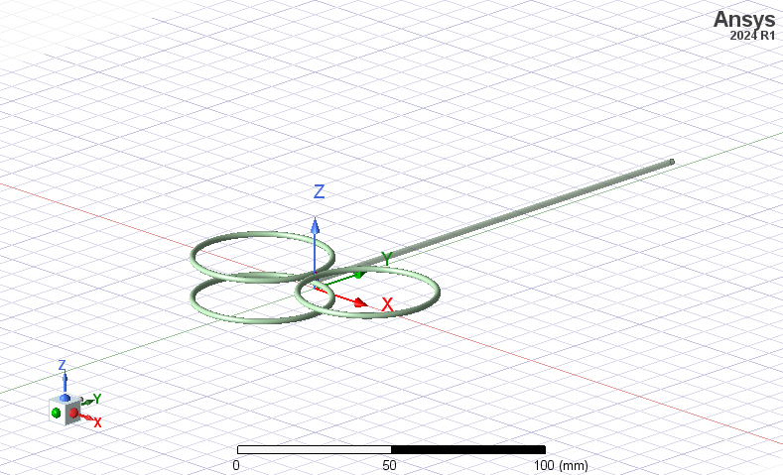Geometry of V14

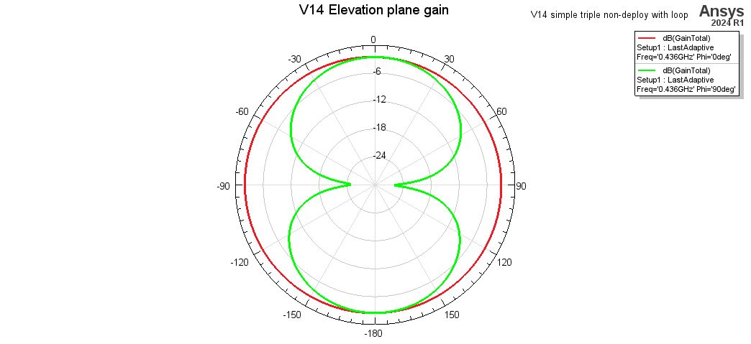Elevation plane gain for triple antenna deployment failure

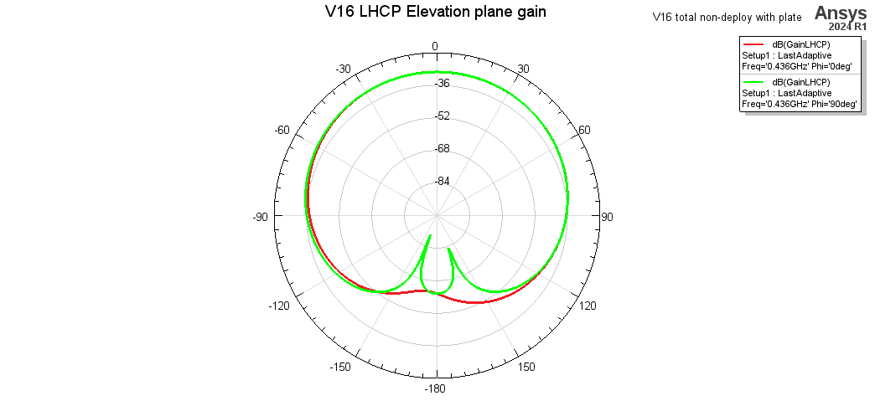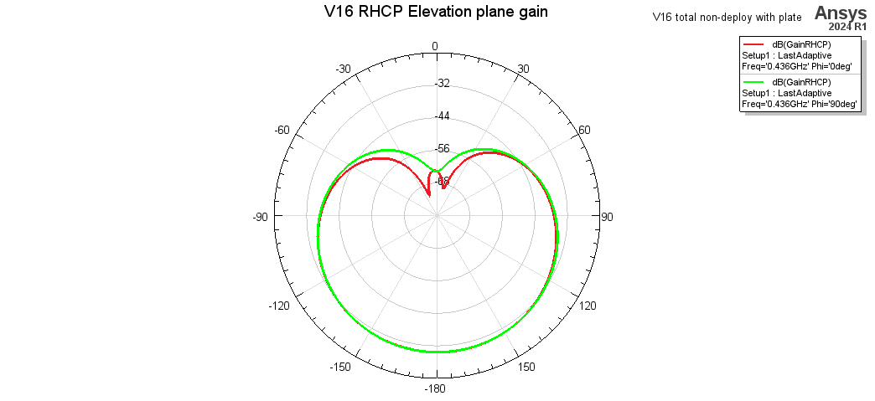Circularly polarized elevation plane gain, (LHCP above, RHCP below)

**Total deployment failure (V16)**

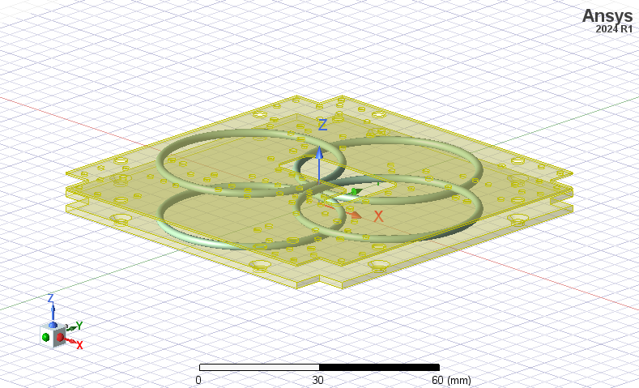Geometry of V16, total deployment failure with plates

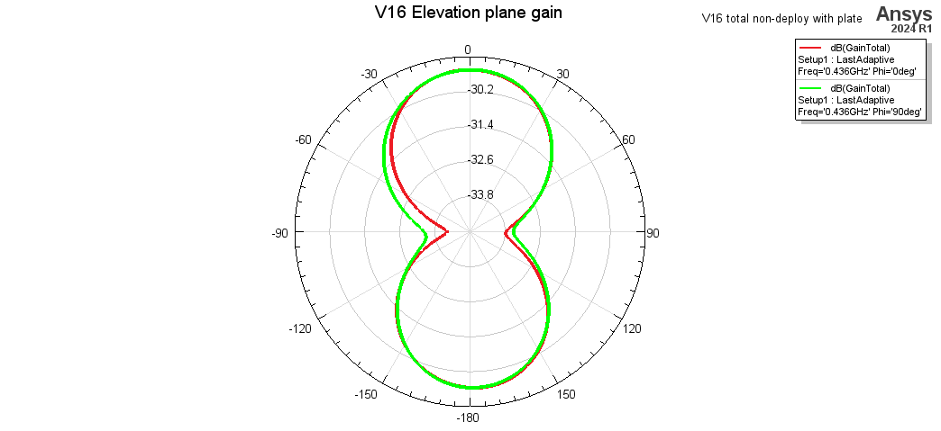Elevation plane gain for total antenna deployment failure with plates

Circularly polarized elevation plane gain, (LHCP above, RHCP below)

**Helpful resources**

For set up and features: [How to Use Ansys Electronics Desktop in Ansys Cloud (youtube.com)](https://www.youtube.com/watch?v=6e8_ymzyQpc)

[](https://www.youtube.com/watch?v=6e8_ymzyQpc)

For basics of antenna design: [ANSYS HFSS: Designing a Dipole Antenna - Part I (youtube.com)](https://www.youtube.com/watch?v=dUC720AJvK0)

[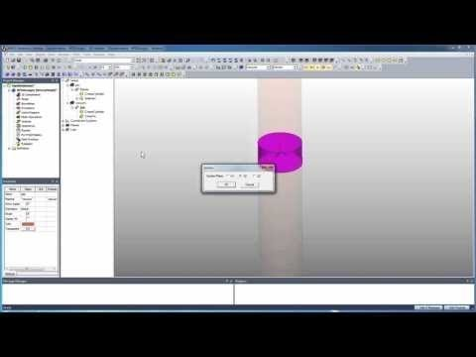](https://www.youtube.com/watch?v=dUC720AJvK0)

A bit more background into various design choices: [HFSSintro.pdf (csus.edu)](https://athena.ecs.csus.edu/~milica/EEE212/HAND/HFSSintro.pdf)

Shape memory alloy investigation: Mechanical properties and constitutive models of shape memory alloy for structural engineering: A review - Ali Mohammadgholipour, AHM Muntasir Billah, 2023 (sagepub.com)

Lumped ports vs wave ports: [PowerPoint Presentation (ansys.com)](https://courses.ansys.com/wp-content/uploads/2021/07/HFSS_GS_2020R2_EN_LE6_Port_Basics.pdf)

Plotting electric field: [HFSS Tutorial: Plotting E-field Magnitude & Phase Along a Line Using Field Calculator](https://www.youtube.com/watch?v=Dr5LHq-zJ-k)

[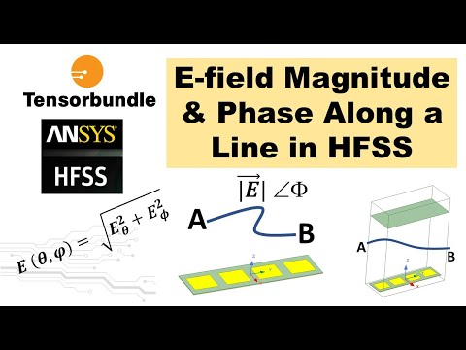](https://www.youtube.com/watch?v=Dr5LHq-zJ-k)